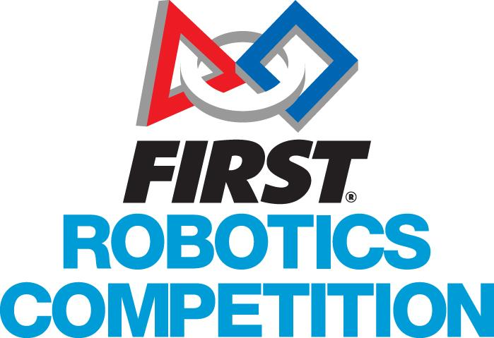
2023 Regional Schedule
Miami Valley Regional
Competition Schedule |  |  | Activities Schedule
(Day 0) – Wednesday – March 15th
6:00PM-8:00PM | 5 Team Reps to Load In and Set Up Pits
(Day 1) – Thursday – March 16th |  |  | (Day 1) – Thursday – March 16th
7:45AM | 5 Team Reps to Load In
8:30AM | Pits, Machine Shop, Registration and Inspection Open
9:00AM-11:00AM | Load-in Ends, Driver’s Meeting, Field Open for Measurement and Calibration
11:00AM-12:00PM | Lunch
12:00PM-6:30PM | Practice Matches |  | 3:00PM – 4:00PM | Women In STEM
8:00PM | Pits and Machine Shop Close
(Day 2) – Friday – March 17th |  |  | (Day 2) – Friday – March 17th
8:00AM | Pits and Machine Shop Open
8:30AM-9:00AM | Opening Ceremonies
9:00AM-12:00PM | Qualification Matches |  | 12:15PM – 12:45PM | FRC Mentor Roundtable
12:00PM-1:00PM | Lunch
1:00PM-5:45PM | Qualification Matches |  | 1:00PM – 4:00PM | Invited Guest Experience & Pit Tours
5:45PM-6:15PM | Awards Ceremony
~6:30PM** | Pits and Machine Shop Close immediately following Awards Ceremony
(Day 3) – Saturday – March 18th |  |  | (Day 3) – Saturday – March 18th
8:00AM | Pits and Machine Shop Open
8:30AM-9:00AM | Opening Ceremonies |  | 9:00AM – 1:00PM | Scholarship Row
9:00AM-12:15PM | Qualification Matches
12:15PM-12:30PM | Alliance Selections |  | 9:00AM – 1:00PM | FIRST LEGO League & FIRST Tech Challenge Demonstrations
12:30PM-1:30PM | Lunch
1:30PM-4:30PM | Playoff Matches & Awards Ceremony
6:30PM | Pits Close
**Schedule subject to change. All times are estimated based on flow of rounds.
See Pit Administration table for updated times.

